User Guide

**Installing:**

In bash do the following:

1. Clone the Repository

Open your terminal or command prompt and clone the GitHub repository to your local machine by running:

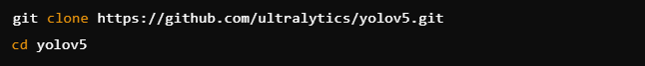

. Install the required dependencies 2

YOLOv5 uses Python and several libraries. You can install the necessary dependencies using pip.

Create a virtual environment (optional but recommended):

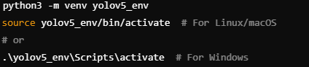

4. Install Required Dependencies

Once the virtual environment is activated, install the necessary Python packages by running:



This will install all the dependencies specified in the requirements.txt file, including:

• PyQt5: For the graphical user interface (GUI).

• SQLite: For database handling.

• Other necessary libraries (e.g., OpenCV, matplotlib, etc.).

5. Running the Application

After the dependencies are installed, you can start the application by running the following command:



So how to use our tool

Common Workflow

A Note of Thanks

We sincerely appreciate your use of our application. Your support and feedback play a crucial role in helping us enhance and develop more valuable tools. We hope this application serves your needs and aids you in your work. Thank you!